Math Teachers’ Circle

American Institute of Mathematics

Palo Alto, CA

**2014-15 Meeting Schedule**

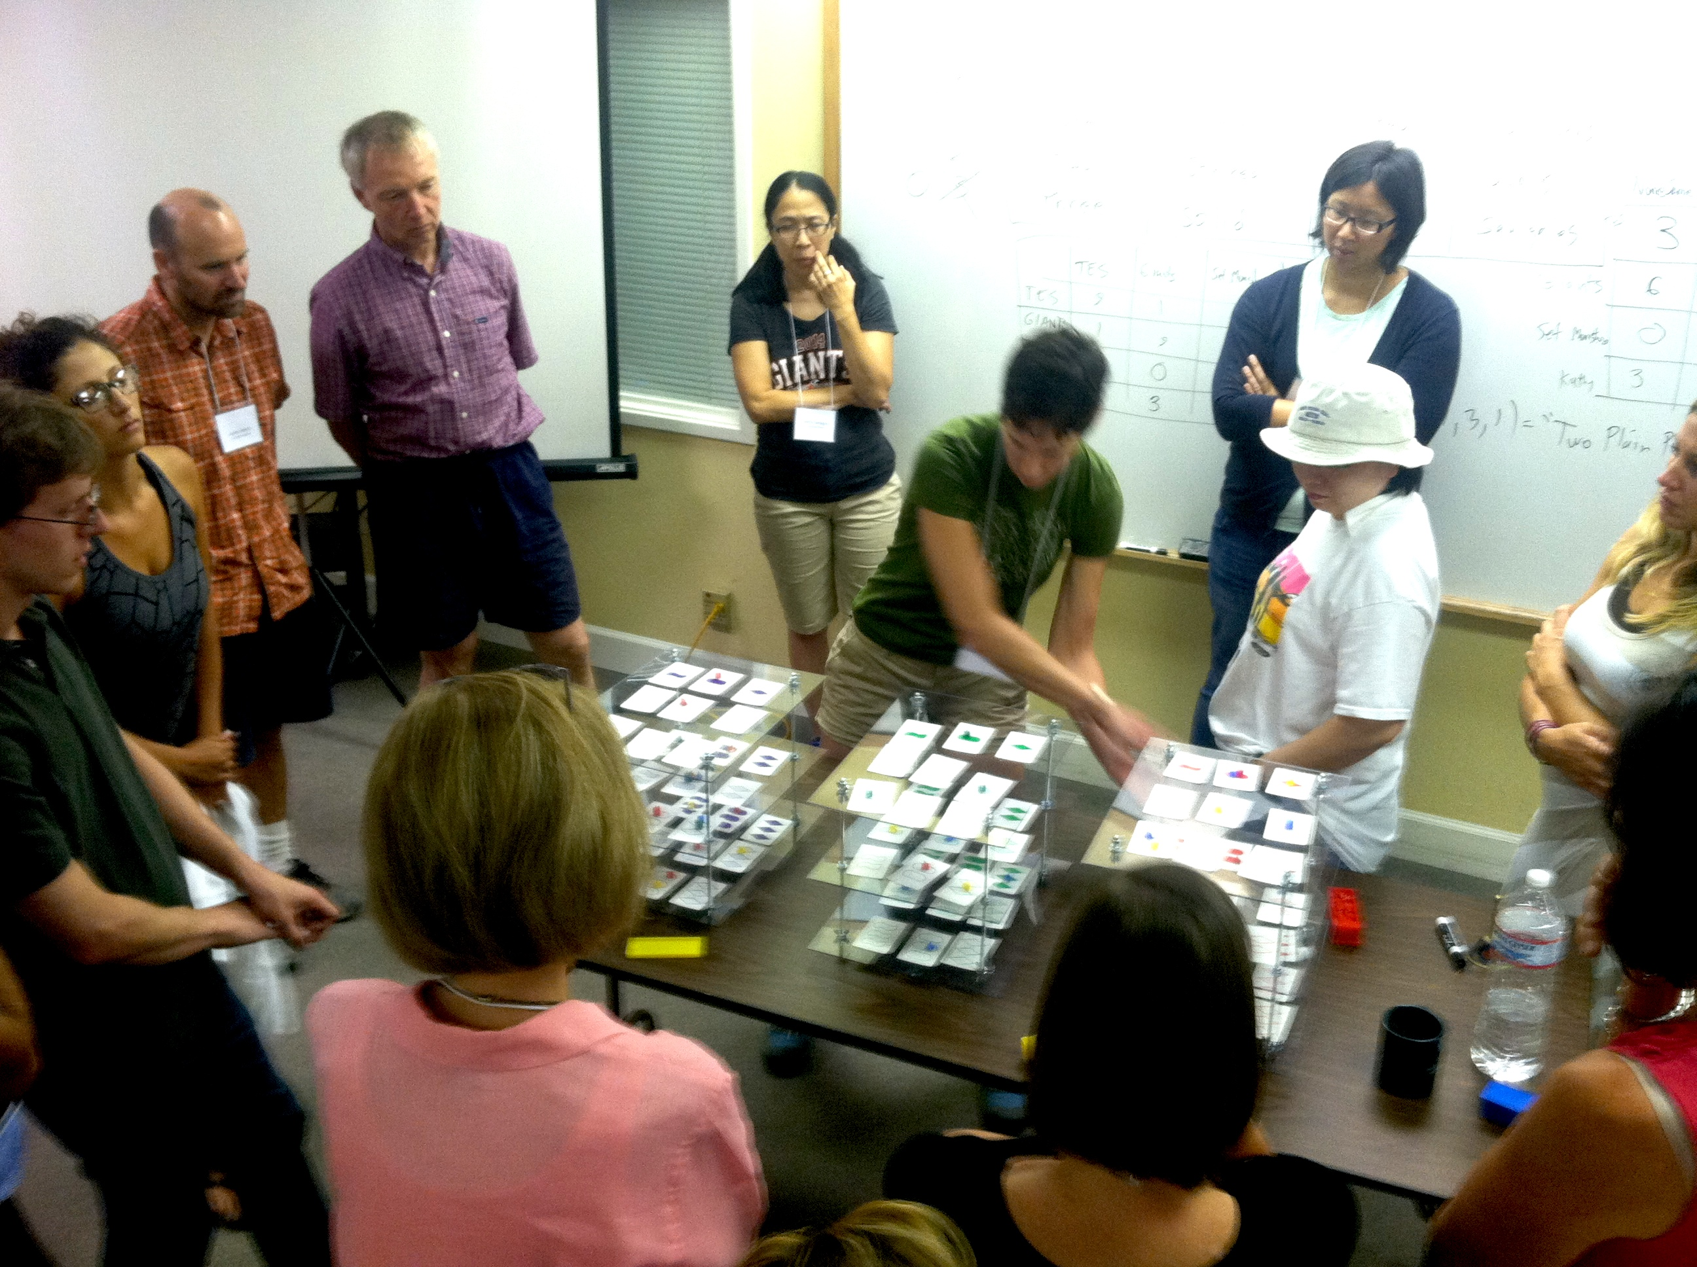

Every month from September to April (except December), the AIM Math Teachers’ Circle will offer an evening meeting for middle school math teachers interested in exploring accessible, exciting topics in mathematics. All teachers are welcome to attend. Meetings include dinner, which is complimentary.

Meetings are held from 5 – 8 PM on the second Tuesday of the month at AIM, unless otherwise specified. The 2014-15 meeting schedule is as follows:

**September 9  
October 7** (first Tuesday) **Novevember 11  
January 13  
February 10  
March 10  
April 14**

For more information, please visit our website [www.mathteacherscircle.org/member-circles/aim/](http://www.mathteacherscircle.org/member-circles/aim/)or contact[hana@aimath.org](mailto:hana@aimath.org)**.**